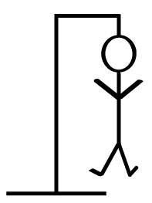

THE H_NGM_N G_ME
Say the word save the nerd

K1526| INT213 | 03-11-2016

1.Ranjan Kumar (11502052)
2.Nischit Shetty (11504254)
3.Hitesh Gandhi (1150)

SUBMITTED TO
MRS.DIMPLE SETHI

INTRODUCTION

A Victorian age game which involves guessing of a word. Originally a pen paper game, hangman game was later on PCs seen as the computers were developing.
Hangman is fun to play which helps in improving vocabulary. Hence, children are encouraged to play this game. It is also a very interesting game which helps in passing of time.

ACKNOWLEDGEMENT

We would like to express our special thanks of gratitude to our teacher Mrs. Dimple Sethi who gave us the golden opportunity to do this wonderful project on the topic ‘THE HANGMAN GAME’, which also helped us in doing a lot of Research and we came to know about so many new things I am thankful to them.
Secondly we would also like to thank our parents and friends who helped us a lot in finalizing this project within the limited time frame.

RULES

- The game consists of a random word which must be guessed by the player.
- A letter should be pressed only once.
- The player will get only 10 number of tries to guess the word.
- Every wrong guess the hangman will be near to death
- After the 10th wrong guess, the hangman dies and the game is over

FUTURE PROSPECTS

Our project has following prospects which will enhance it

We will be working on the graphical UI of the game to make it
more attractive.

Also, there will be a room for improving the efficiency of the game

OUR TEAM
- Ranjan Kumar (11502052)

The logic required for this game was made by Ranjan. He had also played a role in orientation of some graphical components.

- Nischit Shetty(11504254)

Nischit has created the graphics required in the project like the hangman figure, front pages etc.

- Hitesh Gandhi(1150)

Debugging, Error Removal and Linking of Frames was ensured by Hitesh.

